**CSE1007: Java Programming**

**SLOT: L53+L54**

**Faculty: JAISANKAR N**

**LAB Assessment- 2**

**KANDRA KSHEERAJ 19BCE0829**

**Lab Date: 11-02-2021**

1. **Write a Java program to print the third largest number in an array**

import java.util.*;

public class prog1{

public static void thirdLargest(int arr[], int arr_size)

{

if (arr_size < 3)

{

System.out.printf(" Invalid Input ");

return;

}

int first = arr[0];

for (int i = 1; i < arr_size ; i++)

if (arr[i] > first)

first = arr[i];

int second = Integer.MIN_VALUE;

for (int i = 0; i < arr_size ; i++)

if (arr[i] > second &&

arr[i] < first)

second = arr[i];

int third = Integer.MIN_VALUE;

for (int i = 0; i < arr_size ; i++)

if (arr[i] > third &&

arr[i] < second)

third = arr[i];

System.out.printf("The third Largest " + "element is %d", third);

}

public static void main(String []args)

{

Scanner sc = new Scanner(System.in);

System.out.println("Enter the number of elements: ");

int n =sc.nextInt();

System.out.println("Enter the elements of the array: ");

int[] arr = new int[10];

for(int i=0; i<n; i++)

{

arr[i]=sc.nextInt();

}

thirdLargest(arr, n);

}

}

**Sample Output:**

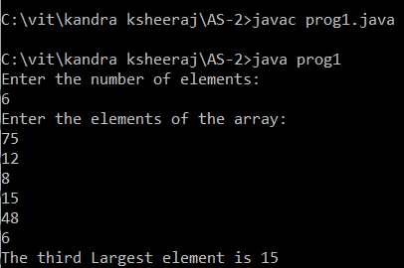

1. **Read the following details of ‘n’ students using Scanner class methods and display the same. - Registration number ( String)**

* **Name (String that may contain first name, middle name and last name)**
* **CGPA (Floating point number)**
* **Programme Name(String)**
* **School Name (String with multiple words)**
* **Proctor Name (String that may contain first, middle and last names)**

1. **Write a Java program to sort an array of positive integers of an given array, in the sorted array the value of the first element should be maximum, second value should be minimum value, third should be second maximum, fourth second be second minimum and so on.**

import java.util.*;

public class prog3 {

public static void rearrange(int arr[], int n)

{

int max_idx = n - 1, min_idx = 0;

int max_elem = arr[n - 1] + 1;

for (int i = 0; i < n; i++) {

if (i % 2 == 0) {

arr[i] += (arr[max_idx] % max_elem) * max_elem;

max_idx--;

}

else {

arr[i] += (arr[min_idx] % max_elem) * max_elem;

min_idx++;

}

}

for (int i = 0; i < n; i++)

arr[i] = arr[i] / max_elem;

}

public static void main(String args[])

{

Scanner sc = new Scanner(System.in);

System.out.println("Enter the number of elements: ");

int n =sc.nextInt();

System.out.println("Enter the elements of the array: ");

int[] arr = new int[10];

for(int i=0; i<n; i++)

{

arr[i]=sc.nextInt();

}

System.out.println("Original Array: ");

for (int i = 0; i < n; i++)

System.out.print(arr[i] + " ");

rearrange(arr, n);

System.out.print("\nModified Array: \n");

for (int i = 0; i < n; i++)

System.out.print(arr[i] + " ");

}

}

**Sample Output:**

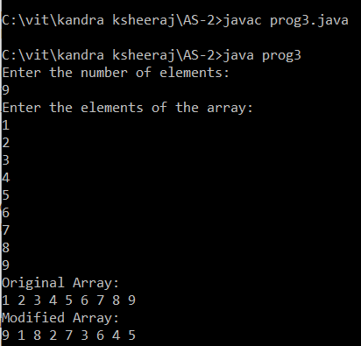

1. **Write a Java program to separate even and odd numbers of an given array of integers. Put all even numbers first, and then odd numbers.**
2. **Write a Java program to convert a binary number to decimal number and to decimal number to binary number.**

import java.util.*;

public class prog5{

public static void main(String args[])

{

Scanner s=new Scanner(System.in);

System.out.println("Enter a binary number:");

int n=s.nextInt();

int decimal=0,p=0;

while(n!=0)

{

decimal+=((n%10)*Math.pow(2,p));

n=n/10;

p++;

}

System.out.println("Corresponding Decimal number:");

System.out.println(decimal);

}

}

**Sample Output:**

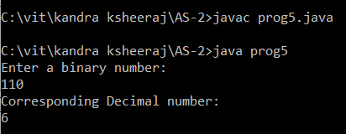

import java.util.*;

public class prog5b{

public static void toBinary(int decimal){

int binary[] = new int[40];

int index = 0;

while(decimal > 0){

binary[index++] = decimal%2;

decimal = decimal/2;

}

for(int i = index-1;i >= 0;i--){

System.out.print(binary[i]);

}

System.out.println();//new line

}

public static void main(String args[]){

Scanner s=new Scanner(System.in);

System.out.println("Enter a decimal number:");

int n=s.nextInt();

System.out.println("correaponding binary: ");

toBinary(n);

}}

**Sample Output:**

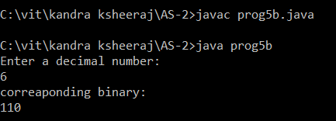

1. **Write a Java program to test if the first and the last element of an array of integers are same. The length of the array must be greater than or equal to 2.   
   Test Data: array = 50, -20, 0, 30, 40, 60, 10  
   Sample Output:**

**False**

import java.util.*;

public class prog6{

public static void main(String[] args)

{

Scanner sc = new Scanner(System.in);

System.out.println("Enter the number of elements: ");

int n =sc.nextInt();

System.out.println("Enter the elements of the array: ");

int[] arr = new int[10];

for(int i=0; i<n; i++)

{

arr[i]=sc.nextInt();

}

System.out.println (arr.length >= 2 && arr[0] == arr[arr.length-1]);

}

}

**Sample Output:**

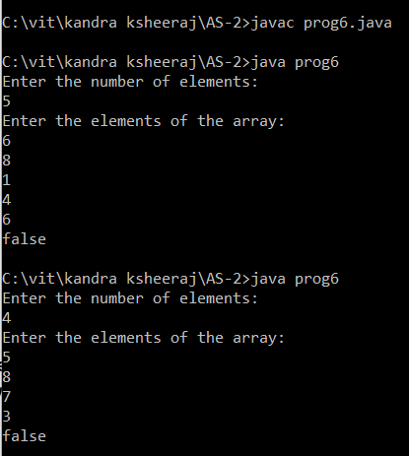

1. **Write a Java program to test if the first and the last element of two array of integers are same. The length of the array must be greater than or equal to   
   Test Data: array1 = 50, -20, 0, 30, 40, 60, 12  
   array2 = 45, 20, 10, 20, 30, 50, 11  
   Sample Output:**

**false**

**import java.util.*;**

**public class prog7 {**

**public static void main(String[] args)**

**{**

**Scanner sc = new Scanner(System.in);**

**System.out.println("Enter the number of elements: ");**

**int n =sc.nextInt();**

**System.out.println("Enter the elements of the array1: ");**

**int[] array1 = new int[7];**

**for(int i=0; i<n; i++)**

**{**

**array1[i]=sc.nextInt();**

**}**

**System.out.println("Enter the elements of the array2: ");**

**int[] array2 = new int[7];**

**for(int i=0; i<n; i++)**

**{**

**array2[i]=sc.nextInt();**

**}**

**if(array1.length>=2 && array2.length>=2)**

**{**

**System.out.println(array1[0] == array2[0] || array1[array1.length-1] == array2[array2.length-1]);**

**}**

**else**

**{**

**System.out.println("Array lengths less than 2.");**

**}**

**}**

**}**

**Sample Output:**

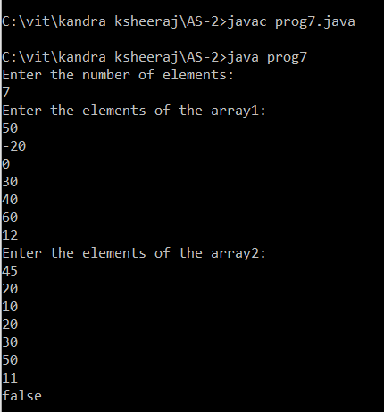

1. **Write a Java program to create a new array of length 2 from two arrays of integers with three elements and the new array will contain the first and last elements from the two arrays   
   Test Data: array1 = 50, -20, 0  
   array2 = 5, -50, 10  
   Sample Output:**

**Array1: [50, -20, 0]**

**Array2: [5, -50, 10]**

**New Array: [50, 10]**

**import java.util.*;**

**public class prog8{**

**public static void main(String[] args)**

**{**

**Scanner sc = new Scanner(System.in);**

**System.out.println("Enter the elements of the array1: ");**

**int[] array1 = new int[3];**

**for(int i=0; i<3; i++)**

**{**

**array1[i]=sc.nextInt();**

**}**

**System.out.println("Enter the elements of the array2: ");**

**int[] array2 = new int[3];**

**for(int i=0; i<3; i++)**

**{**

**array2[i]=sc.nextInt();**

**}**

**System.out.println("Array1: "+Arrays.toString(array1));**

**System.out.println("Array2: "+Arrays.toString(array2));**

**int[] array_new = {array1[0], array2[2]};**

**System.out.println("New Array: "+Arrays.toString(array_new));**

**}**

**}**

**Sample Output:**

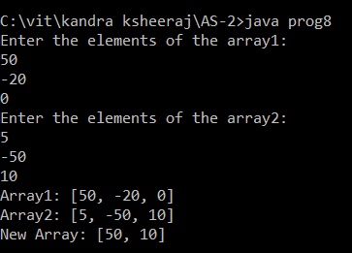

1. **Write a Java program to test that a given array of integers of length 2 contains a 4 or a 7.**

**Sample Output:**

**Original Array: [5, 7]**

**true**

import java.util.*;

public class prog9{

public static void main(String[] args)

{

Scanner sc = new Scanner(System.in);

System.out.println("Enter the elements of the array: ");

int[] arr = new int[2];

for(int i=0; i<2; i++)

{

arr[i]=sc.nextInt();

}

System.out.println("Original Array: "+Arrays.toString(arr));

if(arr[0] == 4 || arr[0] == 7)

System.out.println("True");

else

System.out.println(arr[1] == 4 || arr[1] == 7);

}

}

**Sample Output:**

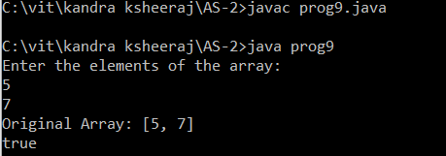

1. **Write a Java program to rotate an array (length 3) of integers in left direction.    
   Sample Output:**

**Original Array: [20, 30, 40]**

**Rotated Array: [30, 40, 20]**

import java.util.*;

public class prog10{

public static void main(String[] args){

Scanner sc = new Scanner(System.in);

System.out.println("Enter the elements of the array: ");

int[] arr = new int[3];

for(int i=0; i<3; i++)

{

arr[i]=sc.nextInt();

}

System.out.println("Original Array: "+Arrays.toString(arr));

int[] new_arr = {arr[1], arr[2], arr[0]};

System.out.println("Rotated Array: "+Arrays.toString(new_arr));

}

}

**Sample Output:**

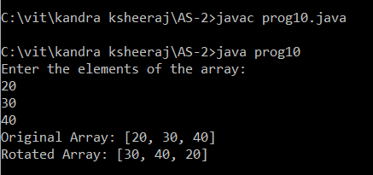

1. **Write a Java program to get the larger value between first and last element of an array (length 3) of integers.    
   Sample Output:**

**Original Array: [20, 30, 40]**

**Larger value between first and last element: 40**

import java.util.*;

public class prog11{

public static void main(String[] args)

{

Scanner sc = new Scanner(System.in);

System.out.println("Enter the elements of the array: ");

int[] arr = new int[3];

for(int i=0; i<3; i++)

{

arr[i]=sc.nextInt();

}

System.out.println("Original Array: "+Arrays.toString(arr));

int max_val = arr[0];

if(arr[2] >= max_val)

max_val = arr[2];

System.out.println("Larger value between first and last element:"+max_val);

}

}

**Sample Output:**

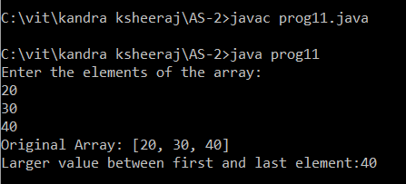

1. **Write a Java program to swap the first and last elements of an array (length must be at least 1) and create a new array.**

**Sample Output:**

**Original Array: [20, 30, 40]**

**New array after swaping the first and last elements: [40, 30, 20]**

**import java.util.*;**

**public class prog12{**

**public static void main(String[] args)**

**{**

**Scanner sc = new Scanner(System.in);**

**System.out.println("Enter the elements of the array: ");**

**int[] arr = new int[3];**

**for(int i=0; i<3; i++)**

**{**

**arr[i]=sc.nextInt();**

**}**

**System.out.println("Original Array: "+Arrays.toString(arr));**

**int x = arr[0];**

**arr[0] = arr[2];**

**arr[2] = x;**

**System.out.println("New array after swaping the first and last elements: "+Arrays.toString(arr));**

**}**

**}**

**Sample Output:**

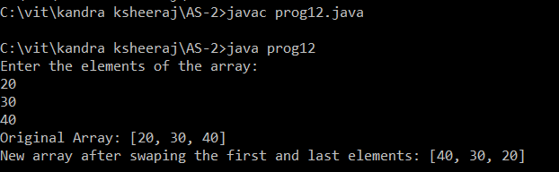

1. **Write a Java program to find the largest element between first, last, and middle values from an array of integers (even length).**

**Sample Output:**

**Original Array: [20, 30, 40, 50, 67]**

**Largest element between first, last, and middle values: 67**

import java.util.*;

public class prog13{

public static void main(String[] args)

{

Scanner sc = new Scanner(System.in);

System.out.println("Enter the number of elements: ");

int n =sc.nextInt();

System.out.println("Enter the elements of the array: ");

int[] arr = new int[10];

for(int i=0; i<n; i++)

{

arr[i]=sc.nextInt();

}

System.out.println("Original Array: "+Arrays.toString(arr));

int max_val = arr[0];

if(max_val <= arr[arr.length-1])

max_val = arr[arr.length-1];

if(max_val <= arr[arr.length/2])

max_val = arr[arr.length/2];

System.out.println("Largest element between first, last, and middle values: "+max_val);

}

}

**Sample Output:**

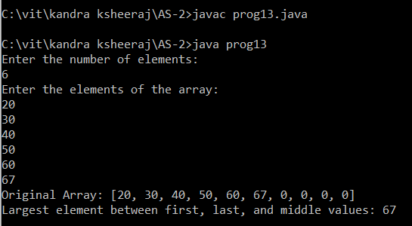

1. **Write a Java program to multiply corresponding elements of two arrays of integers.    
   Sample Output:**

**Array1: [1, 3, -5, 4]**

**Array2: [1, 4, -5, -2]**

**Result: 1 12 25 -8**

import java.util.*;

public class prog14{

public static void main(String[] args){

String result = "";

Scanner sc = new Scanner(System.in);

System.out.println("Enter the number of elements: ");

int n =sc.nextInt();

System.out.println("Enter the elements of the array1: ");

int[] array1 = new int[4];

for(int i=0; i<n; i++)

{

array1[i]=sc.nextInt();

}

System.out.println("Enter the elements of the array2: ");

int[] array2 = new int[4];

for(int i=0; i<n; i++)

{

array2[i]=sc.nextInt();

}

System.out.println("\nArray1: "+Arrays.toString(array1));

System.out.println("\nArray2: "+Arrays.toString(array2));

for (int i = 0; i < array1.length; i++) {

int num1 = array1[i];

int num2 = array2[i];

result += Integer.toString(num1 * num2) + " ";

}

System.out.println("\nResult: "+result);

}

}

**Sample Output:**

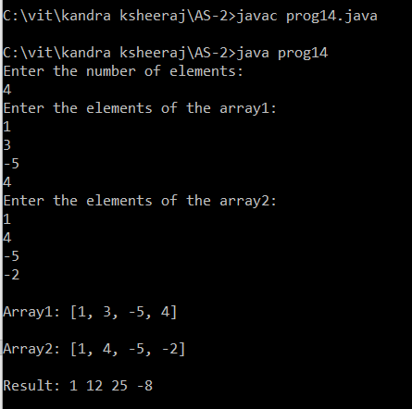

1. **Write a Java program to add two matrix.**

import java.util.*;

public class prog15

{

public static void main(String args[]){

int a[][]={{1,2,3},{1,2,3},{1,2,3}};

int b[][]={{1,3,4},{2,4,3},{1,2,4}};

int c[][]=new int[3][3];

System.out.println("Sum of the 2 matrices:");

for(int i=0;i<3;i++){

for(int j=0;j<3;j++){

c[i][j]=a[i][j]+b[i][j];

System.out.print(c[i][j]+" ");

}

System.out.println();

}

}}

**Sample Output:**

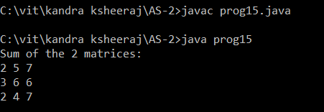

1. **Write a Java program to multiply two matrix.**

import java.util.*;

public class prog16

{

public static void main(String[] args) {

Scanner sc = new Scanner(System.in);

int a[][]={{1,1,1},{2,2,2},{3,3,3}};

int b[][]={{1,1,1},{2,2,2},{3,3,3}};

System.out.println("product of the 2 matrices:");

int c[][]=new int[3][3];

for(int i=0;i<3;i++){

for(int j=0;j<3;j++){

c[i][j]=0;

for(int k=0;k<3;k++)

{

c[i][j]+=a[i][k]*b[k][j];

}

System.out.print(c[i][j]+" ");

}

System.out.println();

}

}

}

**Sample Output:**

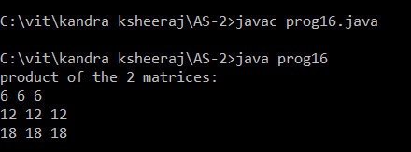

1. **Write a Java program to Calculate diagonal element.**

import java.util.*;

public class prog17

{

public static void main(String args[])

{

Scanner sc = new Scanner(System.in);

int i,j,row,col,sum=0;

System.out.println("Enter the number of rows:");

row = sc.nextInt();

System.out.println("Enter the number of columns:");

col = sc.nextInt();

int[][] mat = new int[row][col];

System.out.println("Enter the elements of the matrix") ;

for(i=0;i<row;i++)

{

for(j=0;j<col;j++)

{

mat[i][j] = sc.nextInt();

}

}

System.out.println("The elements of the matrix") ;

for(i=0;i<row;i++)

{

for(j=0;j<col;j++)

{

System.out.print(mat[i][j]+"\t");

}

System.out.println("");

}

for(i=0;i<row;i++)

{

for(j=0;j<col;j++)

{

if(i==j)

{

sum = sum + mat[i][j];

}

}

}

System.out.printf("Sum of diagonal elements of the matrix = "+sum) ;

}

}

**Sample Output:**

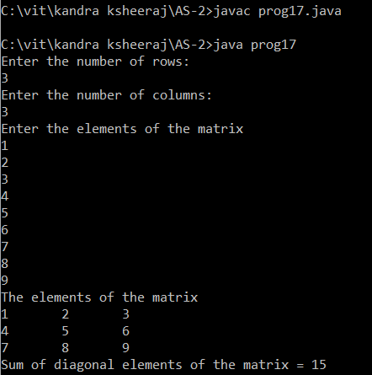

1. **Write a Java Program to print this pattern for n lines**

**1**

**12**

**123**

**1234**

**1234**

**123**

**12**

**1**

import java.util.*;

public class prog18

{

public static void main(String[] args) {

int i, j, rows,nuum;

Scanner sc = new Scanner(System.in);

System.out.print("Enter the number of rows : ");

rows = sc.nextInt();

for (i= 0; i<= rows-1; i++)

{

for (j=0; j<=i; j++)

{

System.out.print(j+1+ " ");

}

System.out.println("");

}

for (i=rows-1; i>=0; i--)

{

for(j=0; j <= i-1;j++)

{ nuum=j+1;

System.out.print(nuum+ " ");

}

System.out.println("");

}

}

}

**Sample Output:**

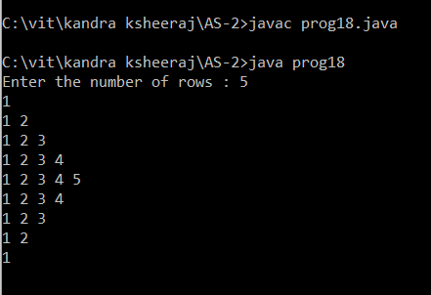

1. **Write a program to demonstrate the knowledge of students in multidimensional arrays and looping constructs.   
   Eg., If there are 4 batches in BTech - “CSE1007” course, read the count of the slow learners (who have scored <25) in each batch. Tutors should be assigned in the ratio of 1:4 (For every 4 slow learners, there should be one tutor). Determine the number of tutors for each batch. Create a 2-D jagged array with 4 rows to store the count of slow learners in the 4 batches. The number of columns in each row should be equal to the number of groups formed for that particular batch ( Eg., If there are 23 slow learners in a batch, then there should be 6 tutors and in the jagged array, the corresponding row should store 4, 4, 4, 4, 4,3). Use for-each loop to traverse the array and print the details. Also print the number of batches in which all tutors have exactly 4 students.**